Department of Software Engineering
Mehran University of Engineering and Technology, Jamshoro

Course: SW321 – Computer networks and management
Instructor | Rabeea Jaffari | Practical/Lab No. | 05
Date |  | CLOs | CLO-3: P5 & CLO-4: P3
Signature |  | Assessment Score | 1 Mark

Topic | To design a peer to peer network.
Objectives | - To be able to physically cable a peer-to-peer and switched network

Lab Discussion: Theoretical concepts and Procedural steps

BACKGROUND:

Many network problems can be fixed at the Physical layer of a network. For this reason, it is important to have a clear understanding of which cables to use for your network connections. At the Physical (Layer1) of the OSI model, end devices must be connected by media (cables). The type of media required depends on the type of device being connected. In the basic portion of this lab straight–through cables will be used to connect workstations and switches. In addition, two or more devices communicate through an address. The Network layer (Layer 3) requires a unique address (also known as a logical address or IP Addresses), which allows the data to reach the Appropriate destination device. Addressing for this lab will be applied to the workstations and will be used to enable communication between the devices.

Scenario
This lab starts with the simplest form of networking (peer-to-peer) and ends with the lab connecting through a network switch.

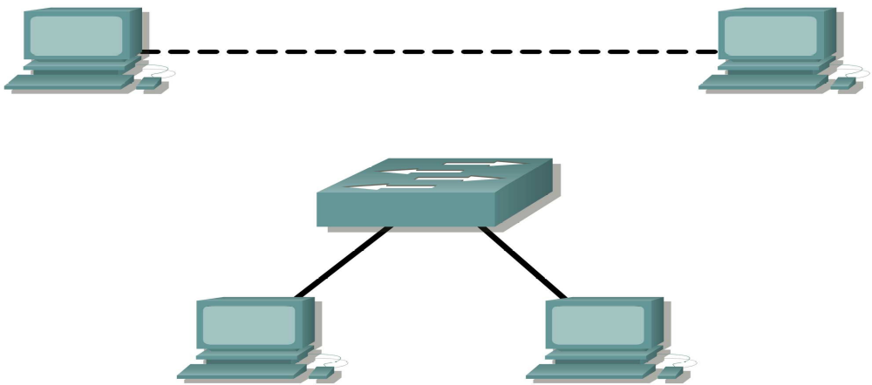

Figure 1 Switched network
Task 1: Create a Peer-to-Peer Network.
Step 1: Select a lab partner.
Step 2: Obtain equipment and resources for the lab.
Equipment needed:
2 workstations
2 straight through (patch) cables
1 crossover cable
1 switch (or hub)

Task 2: Identify the Cables used in a Network
Before the devices can be cabled, you will need to identify the types of media you will be using. The
cables used in this lab are crossover and straight-through.
Use a crossover cable to connect two workstations to each other through their NIC’s Ethernet port. This
is an Ethernet cable. When you look at the plug you will notice that the orange and green wires are in
opposite positions on each end of the cable.
Use a straight-through cable to connect the router’s Ethernet port to a switch port or a workstation to a
switch port. This is also an Ethernet cable. When you look at the plug you will notice that both ends of the
cable are exactly the same in each pin position.

Task 3: Cable the Peer-to-peer Network

Step 1: Connect two workstations.
Using the correct Ethernet cable, connect two workstations together. Connect one end of the cable to the NIC port on PC1 and the other end of the cable to PC2.

Step 2: Apply a Layer 3 address to the workstations.
To complete this task, you will need to follow the step-by-step instructions below.
Note: These steps must be completed on each workstation.
may differ slightly if you are using a different operating system.
1. On your computer, click Start, right-click My Network Places, and then click Properties. The
Network Connections window should appear, with icons showing the different network
connections.
2. Right-click the Local Area Connection and click Properties.
3. Select the Internet Protocol (TCP/IP) item and then click the Properties button.
4. On the General tab of the Internet Protocol (TCP/IP) Properties window, select the Use the
following IP address option.
5. In the IP address box, enter the IP address 192.168.1.2 for PC1. (Enter the IP address
192.168.1.3 for PC2.)
6. Press the tab key and the Subnet mask is automatically entered. The subnet address should be 255.255.255.0. If this address is not automatically entered, enter this address manually.
7. Click OK.
8. Close the Local Area Connection Properties window.

Step 3: Verify connectivity.
On your computer, click Start, and then click Run.
Type cmd in the Open box and then click OK.
The DOS command (cmd.exe) window will appear. You can enter DOS commands using this
window. For the purposes of this lab, basic network commands will be entered to allow you to test
you computer connections.
The ping command is a computer network tool used to test whether a host (workstation, router,
server, etc.) is reachable across an IP network.
3. Use the ping command to verify that PC1 can reach PC2 and PC2 can reach PC1. From the
PC1 DOS command prompt, type ping 192.168.1.3. From the PC2 DOS command prompt,
type ping 192.168.1.2.

If the ping command displays an error message or doesn’t receive a reply from the other
workstation, troubleshoot as necessary. Possible areas to troubleshoot include:
- Verifying the correct IP addresses on both workstations
- Ensuring that the correct type of cable is used between the workstations

Task 4: Connect Your Workstations to the Classroom Lab Switch.

Step 1: Connect workstation to switch.
Using the correct cable, connect one end of the cable to the NIC port on the workstation and the other
end to a port on the switch.
Step 2: Repeat this process for each workstation on your network.
Which cable did you use? ______________________________
Step 3: Verify connectivity.
Verify network connectivity by using the ping command to reach the other workstations attached to the
switch.

Step 4: Share a document between PCs.
1. On your desktop, create a new folder and name it test.
2. Right-click the folder and click File sharing. Note: A hand will be placed under the icon.
3. Place a file in the folder.
4. On the desktop, double-click My Network Places and then Computers Near Me.
5. Double-click the workstation icon. The test folder should appear. You will be able to access this folder across the network. Once you are able to see it and work with the file, you have access through all 7 layers of the OSI model.

Lab Tasks
Submission Date:

Answer the following questions:

- Which cable did you use to connect workstations in Task 3?
- What was the output of ping command in Step 3 of Task 3? What happens if you unplug the network cable and ping the other workstation?
- What was the output of ping command in Task 4? What happens if you ping an address that is not connected to the network?
- What could prevent a ping from being sent between the workstations when they are directly connected?
- What could prevent the ping from being sent to the workstations when they are connected through the switch?

